Largely based on:

The Companion IC by Srijal97 - <http://www.instructables.com/id/The-Companion-IC/>

My code can be found here:

<https://github.com/kd8bxp/multi-tester>

(Why this github repository and not the club one...well I messed up and pushed it to my own)

The above instructables link explains very well how this works.

To get this to work on the UNO I did end up moving some of the pins around a bit, and my code reflects those types of changes.

(I am still having some issues with bounce in my button, so I have not hooked it to a interrupt pin yet) But hooking it to a interrupt was a reason for moving some of the pins.

I also choose to use a I2C OLED screen and not the 1602, thou I think it would be easy enough to change to a 1602 I2C screen if you wanted to.

Here are a few pictures of mine during the build process.

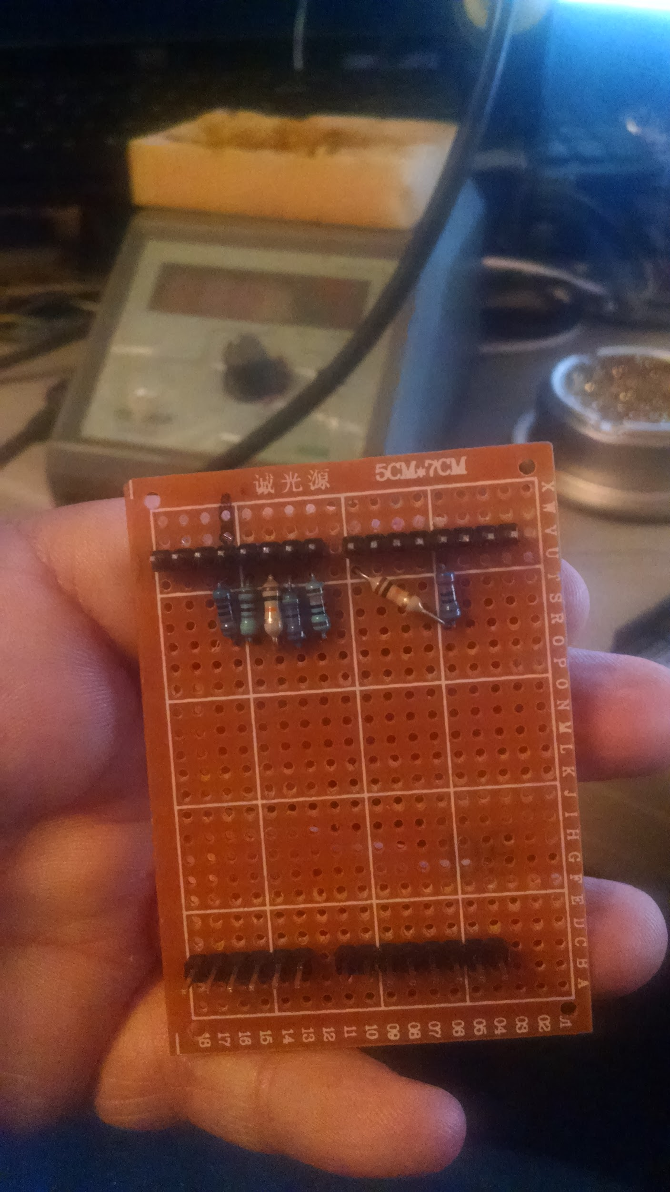

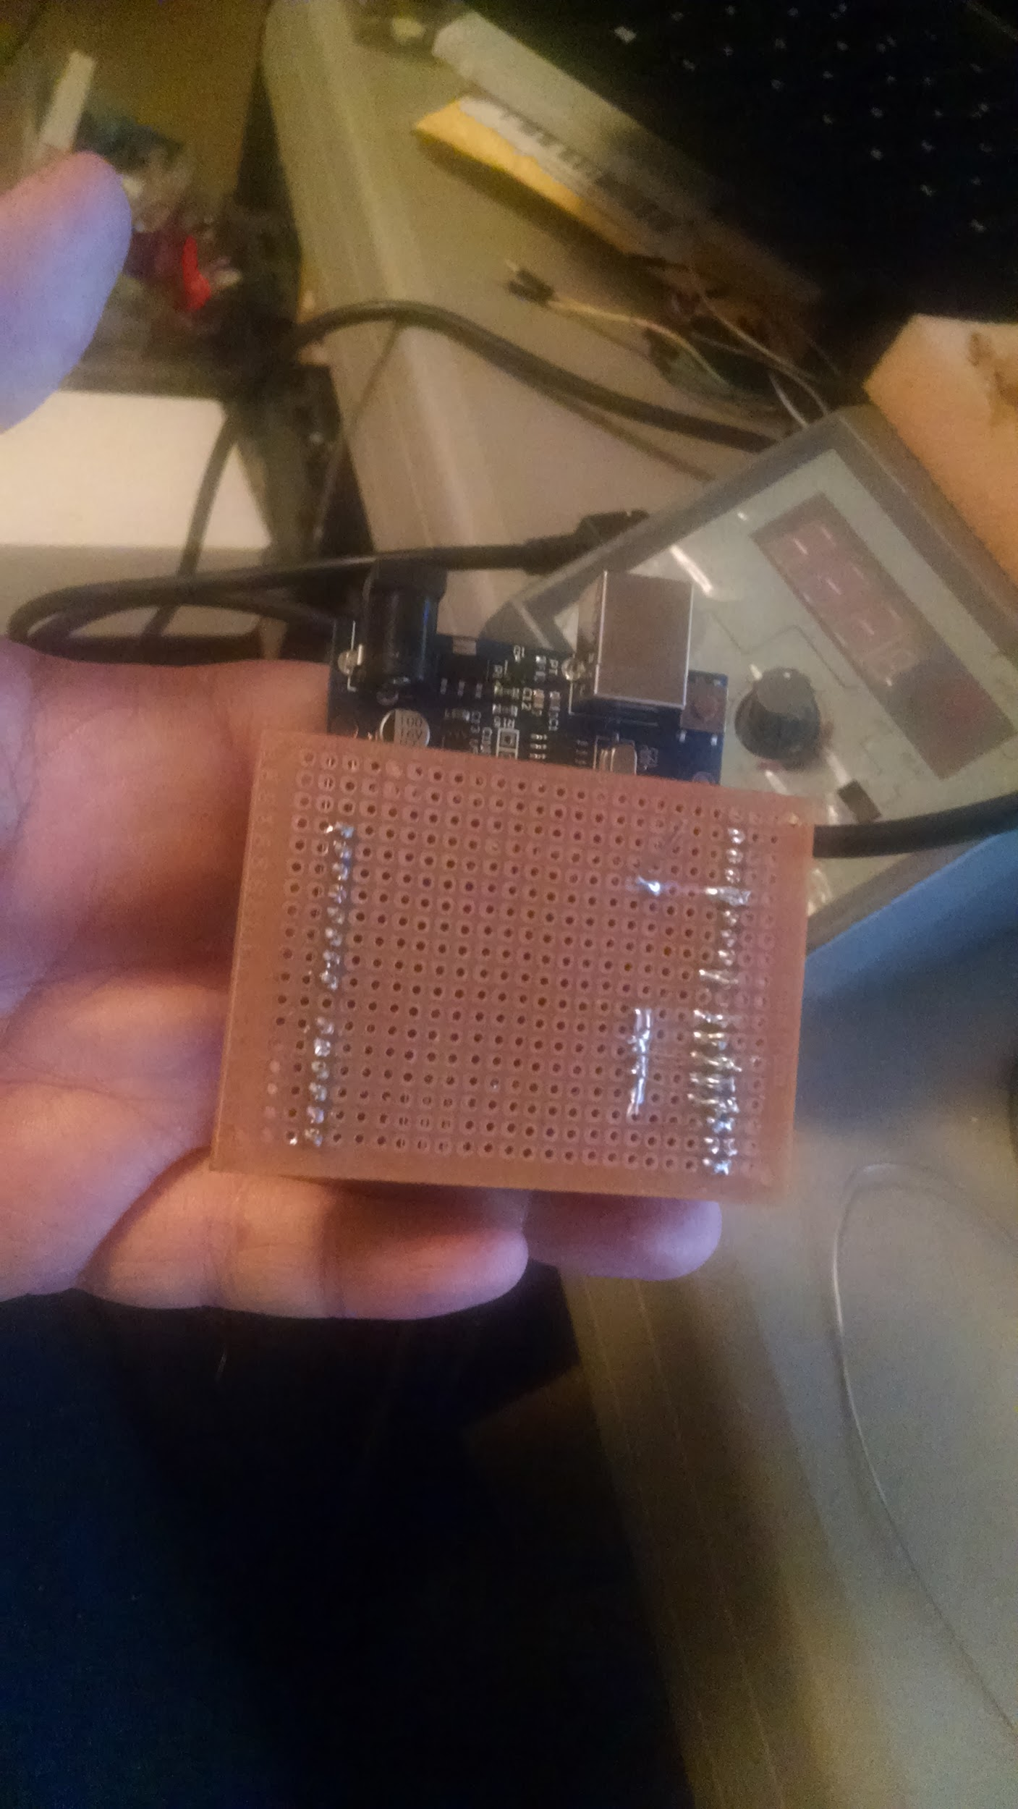

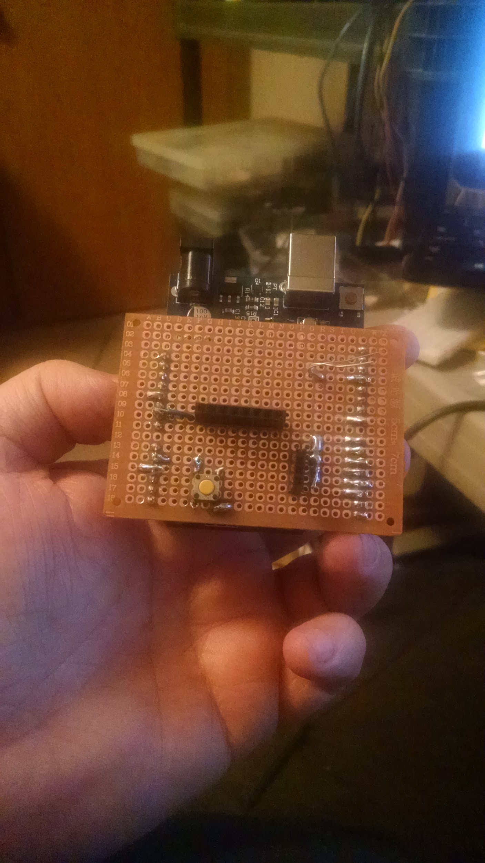

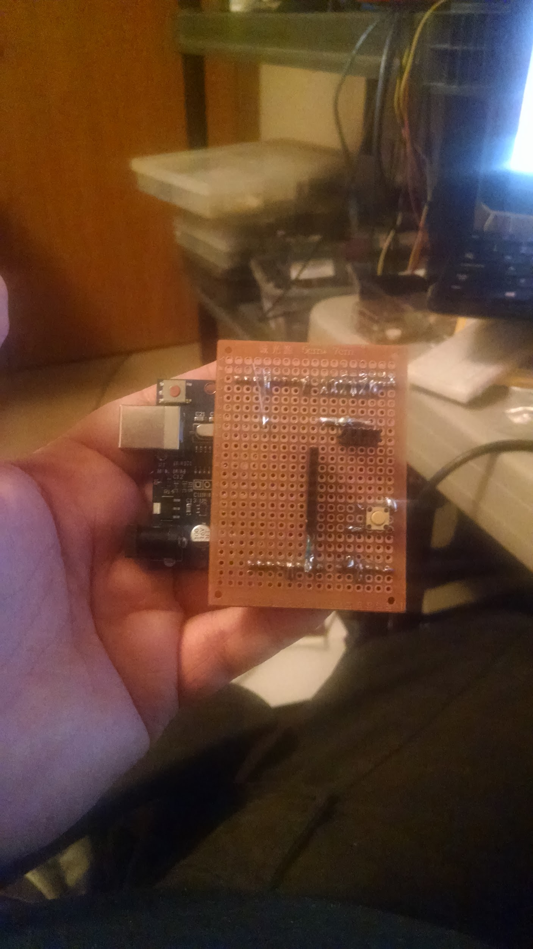

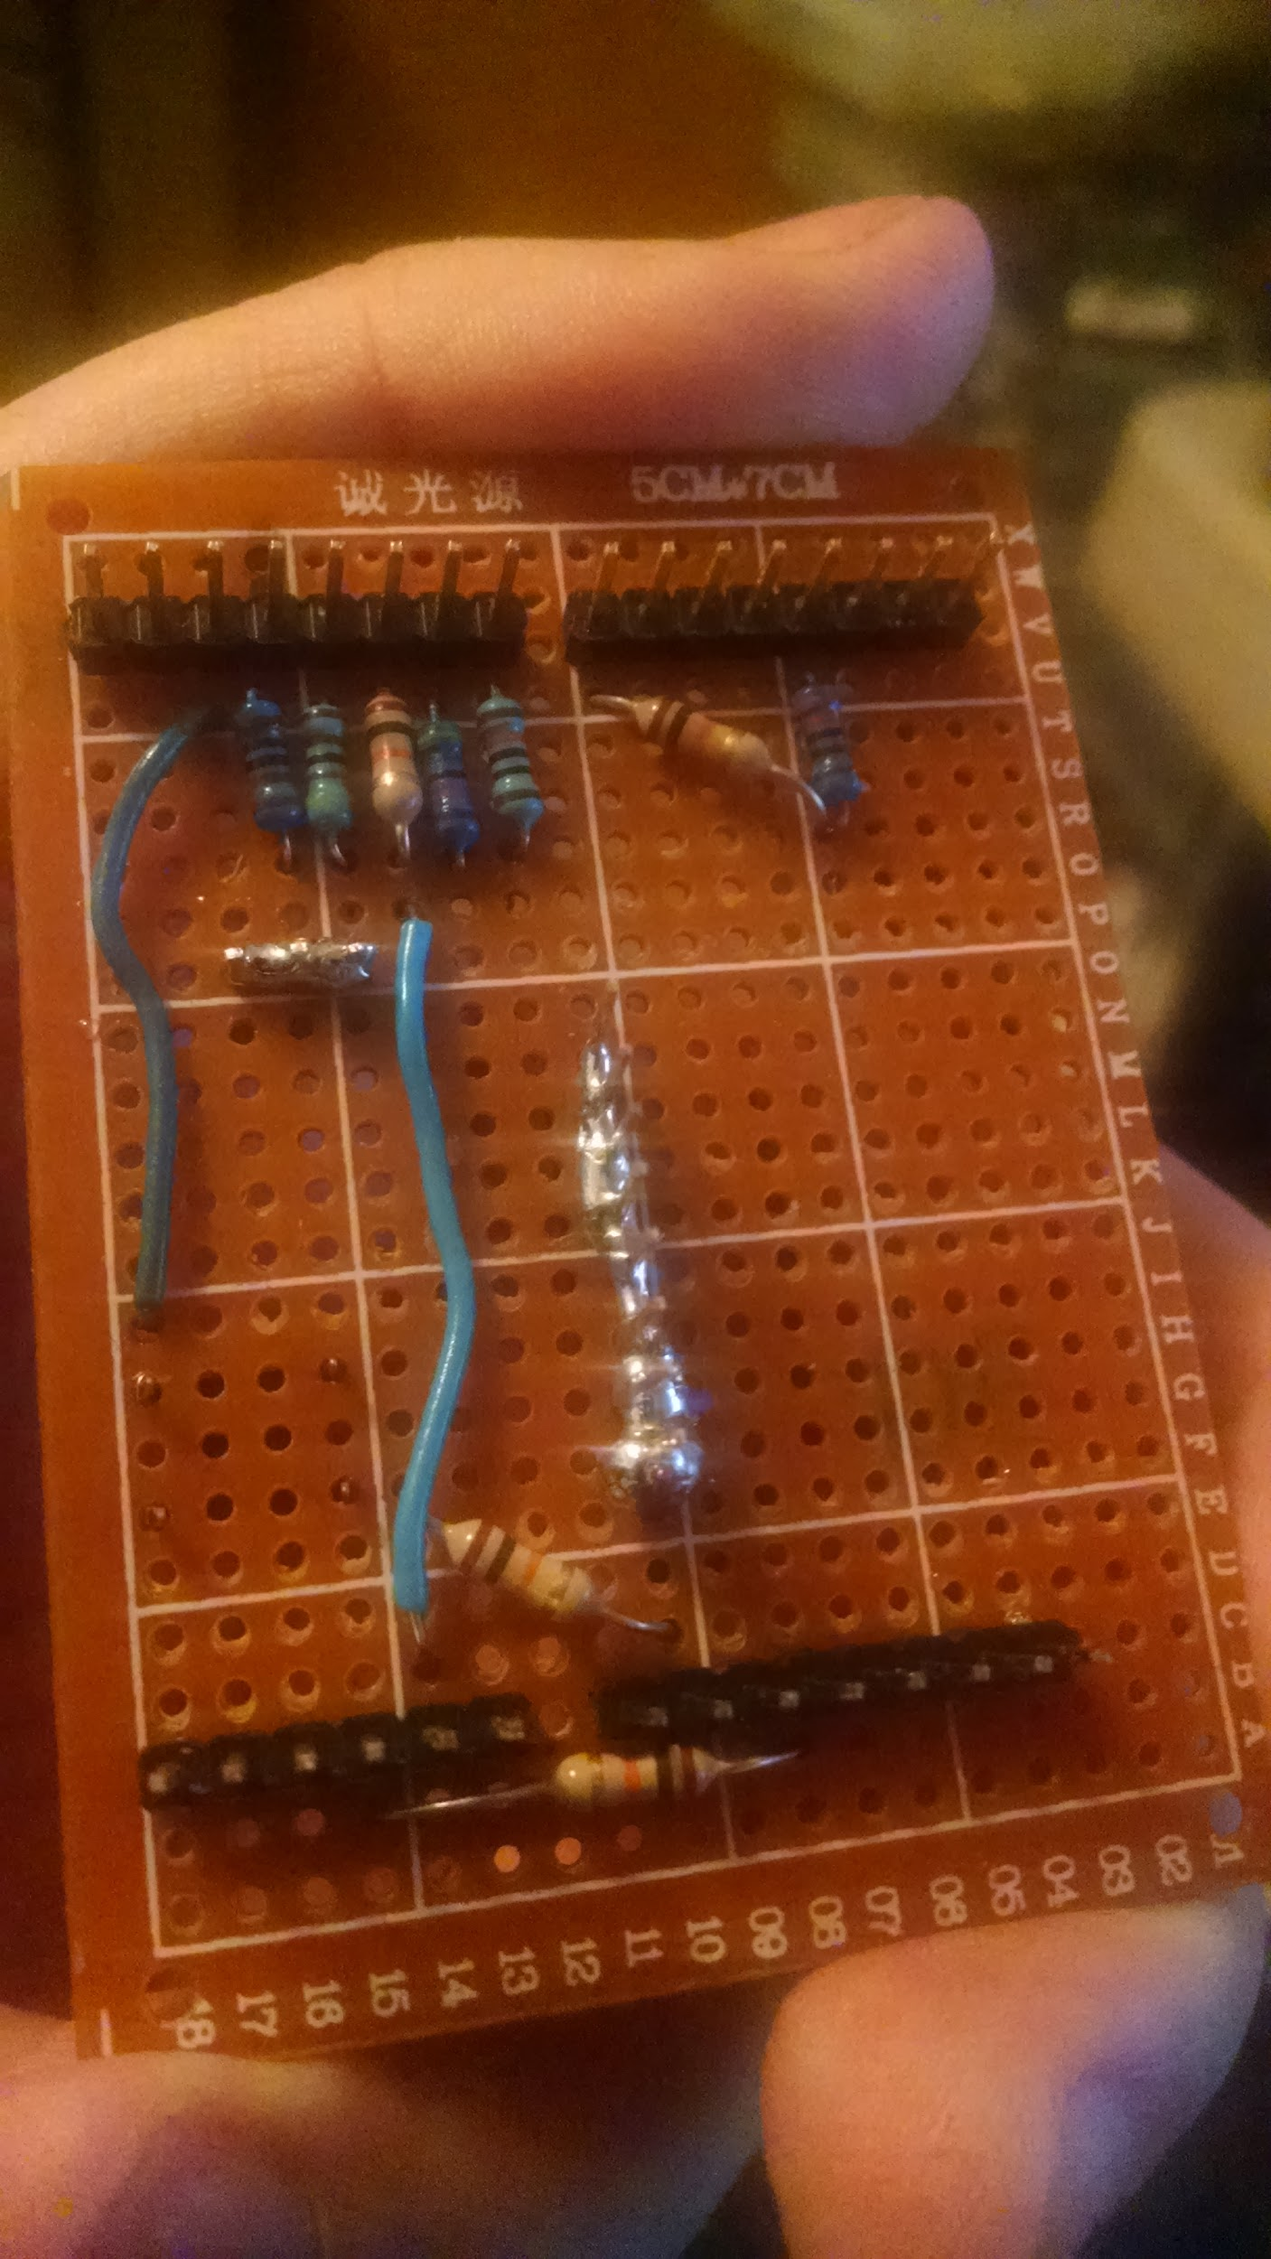

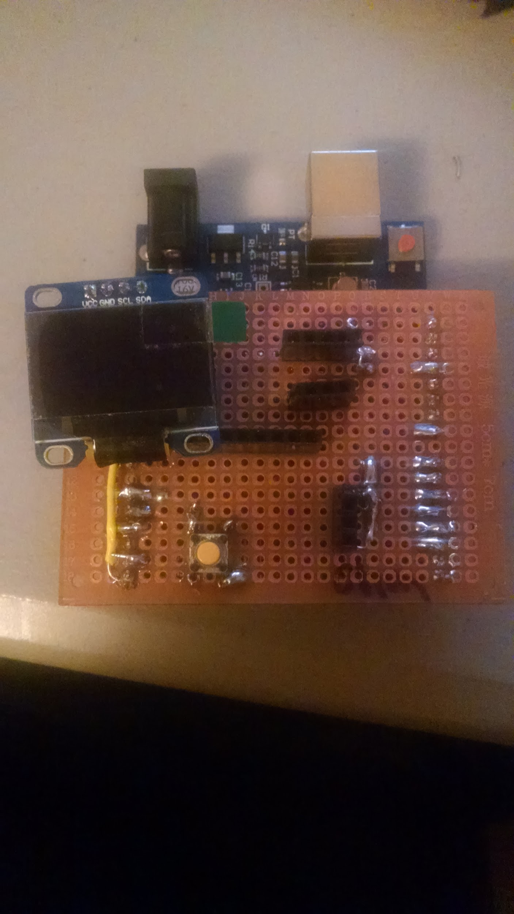

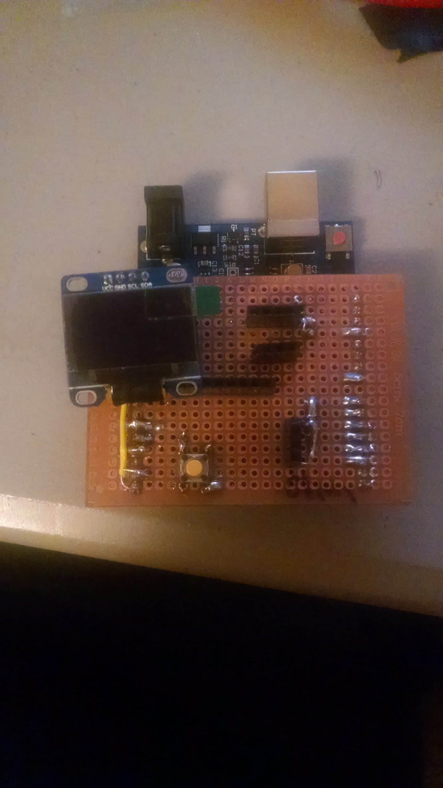

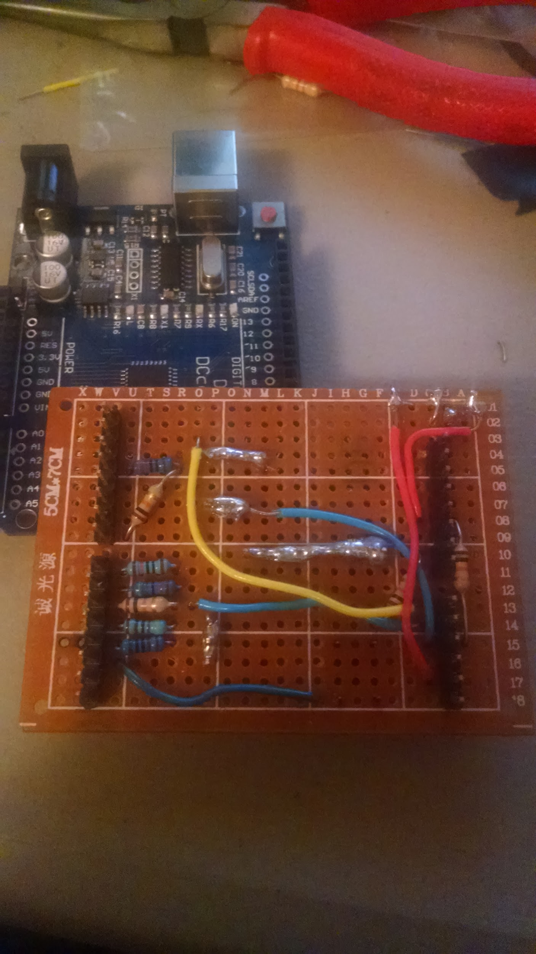

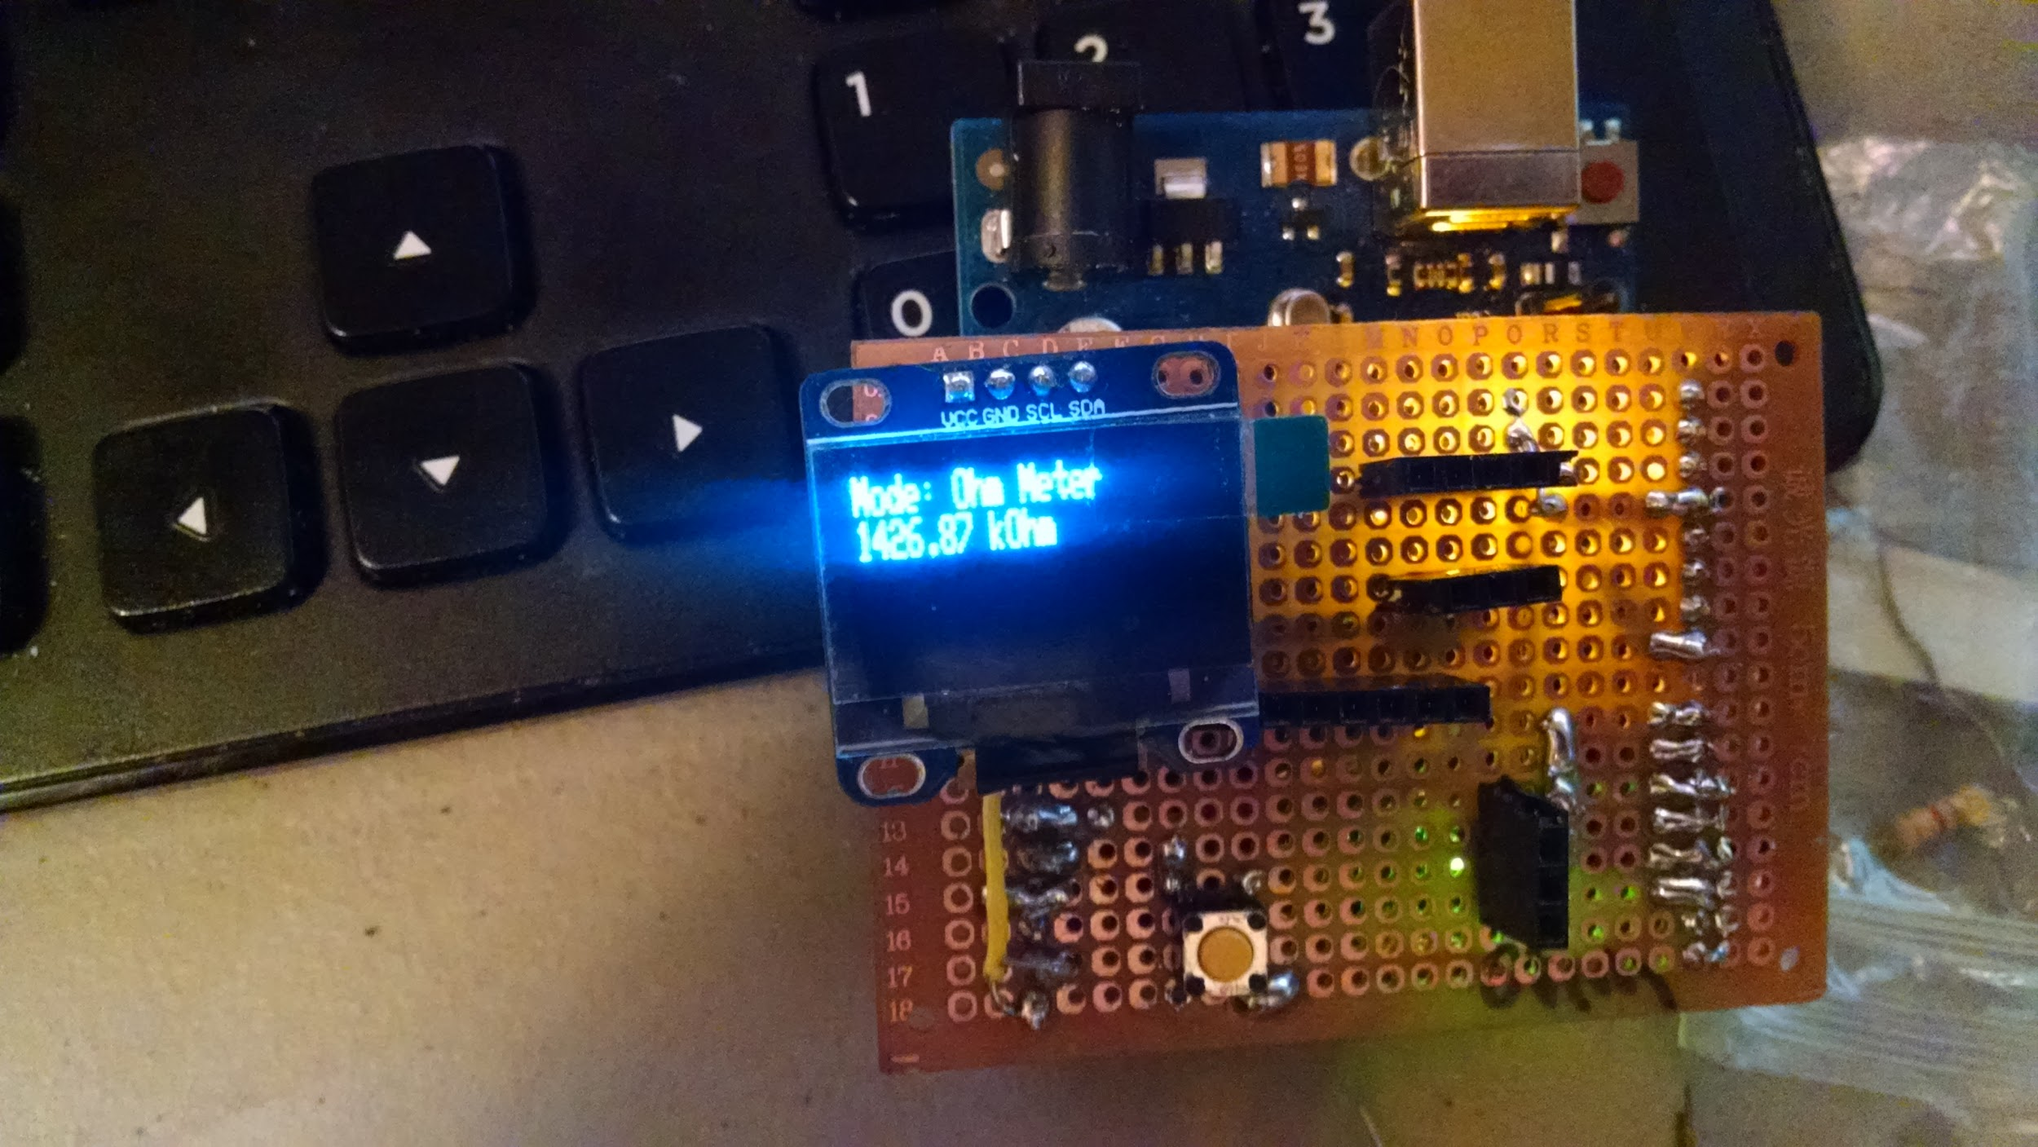

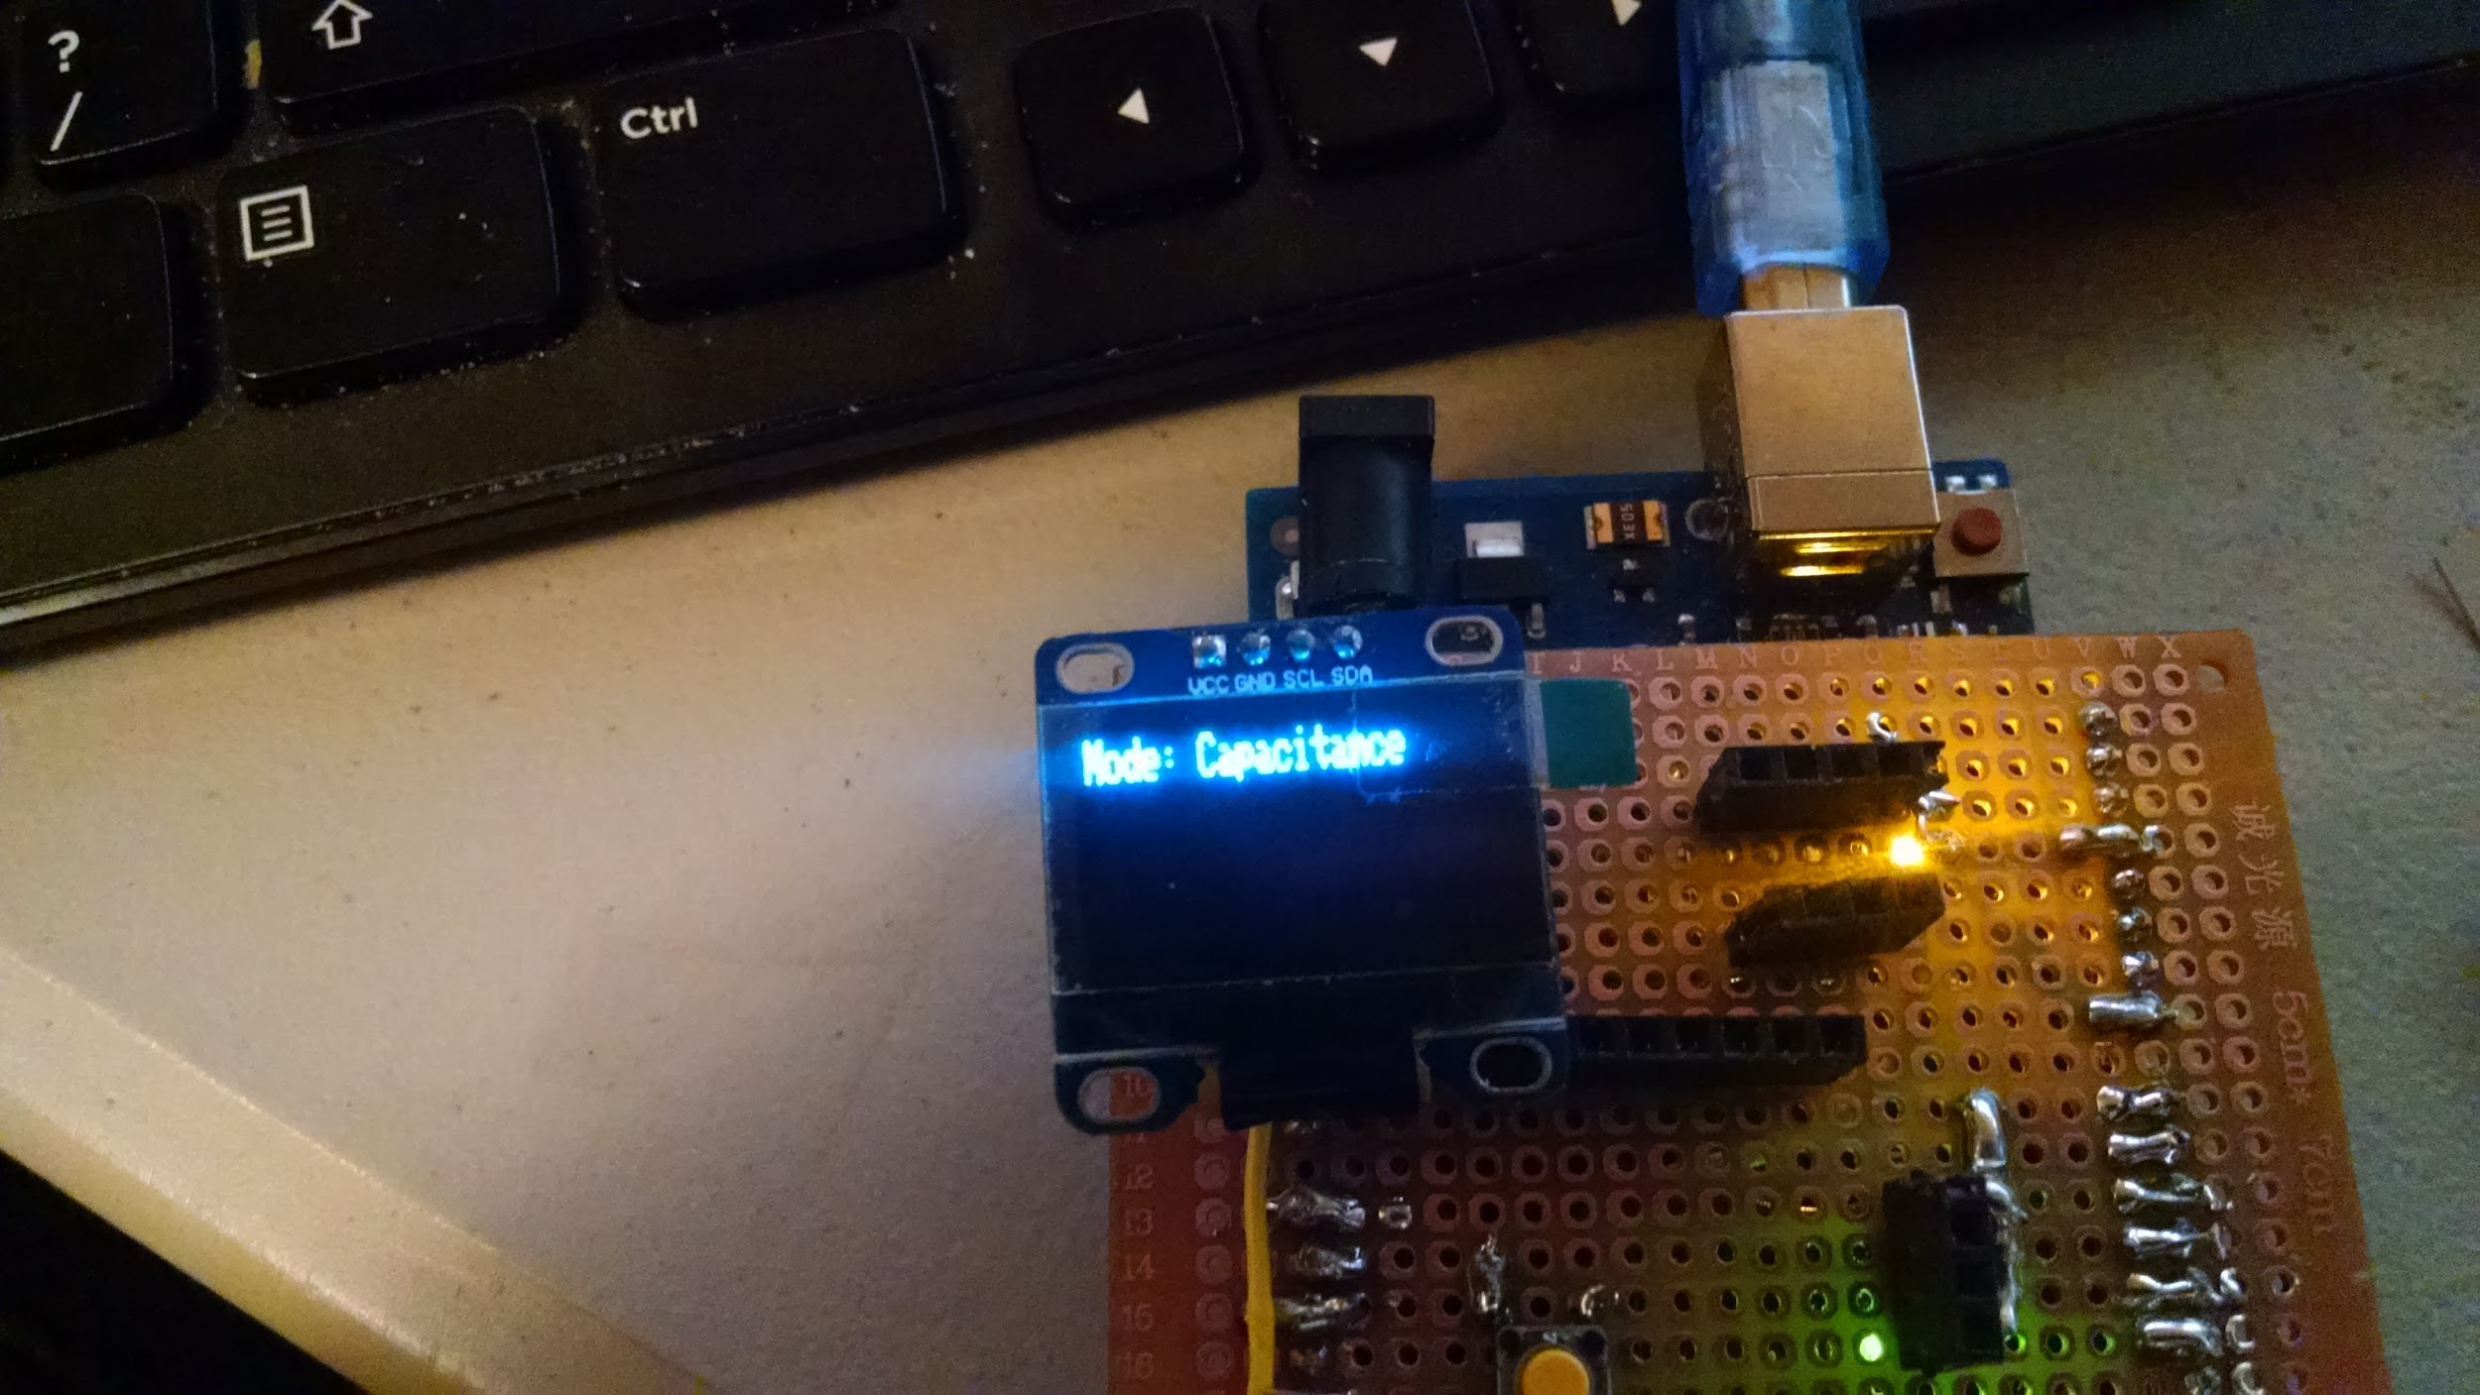

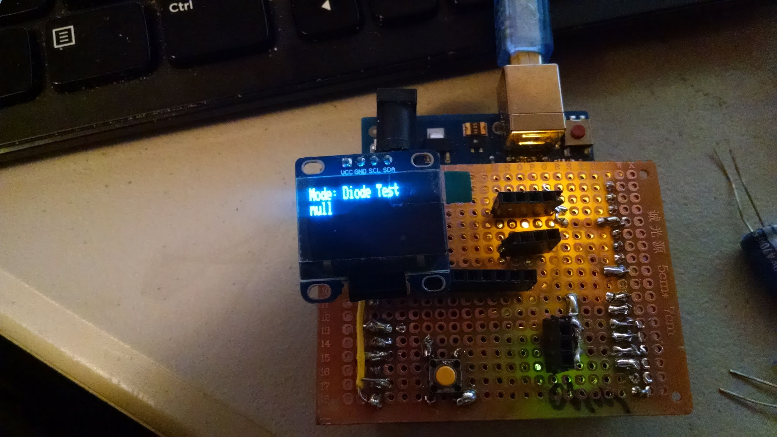

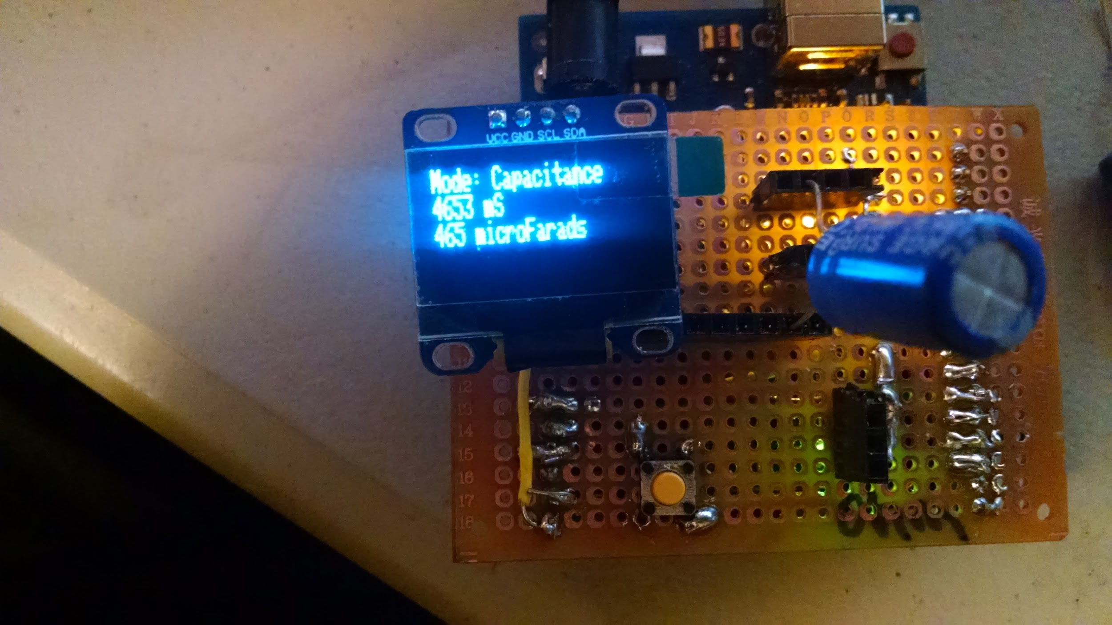

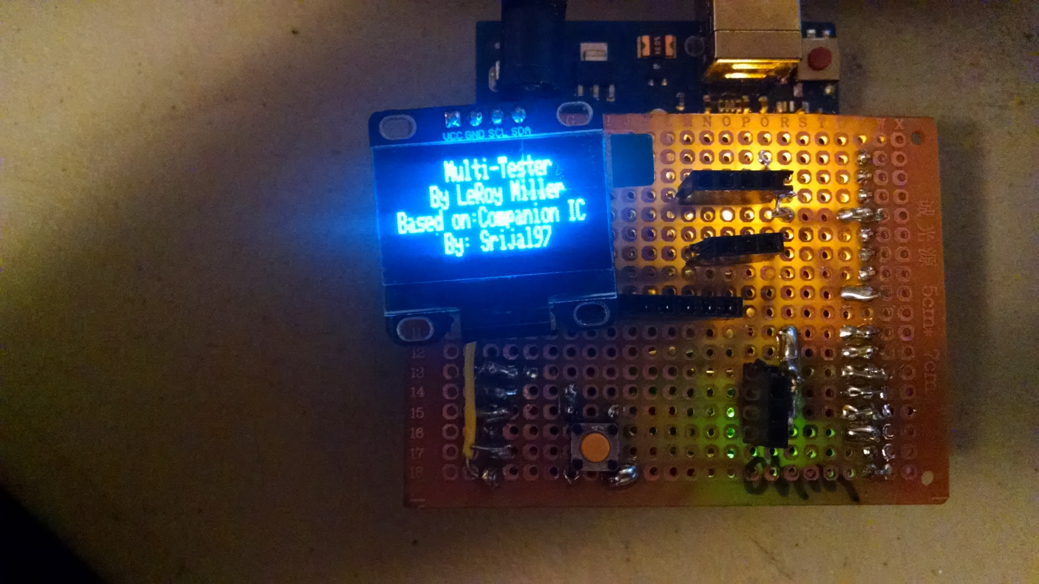

My Pin Reassigments in ( ):

Pins used:

Button D11 (Setup interupt on D2)

Diode:

D12

A6 (Move to A2)

Capacitance:

A0

D7 (Move to D8)

D12

Resistor:

D2 (Move to D3)

D3 (Move to D4)

D4 (Move to D5)

D5 (Move to D6)

D6 (Move to D7)

A7 (Move to A1)

LCD(OLED): (Add)

A4

A5

And a picture of how to use it, explanation of pin headers.

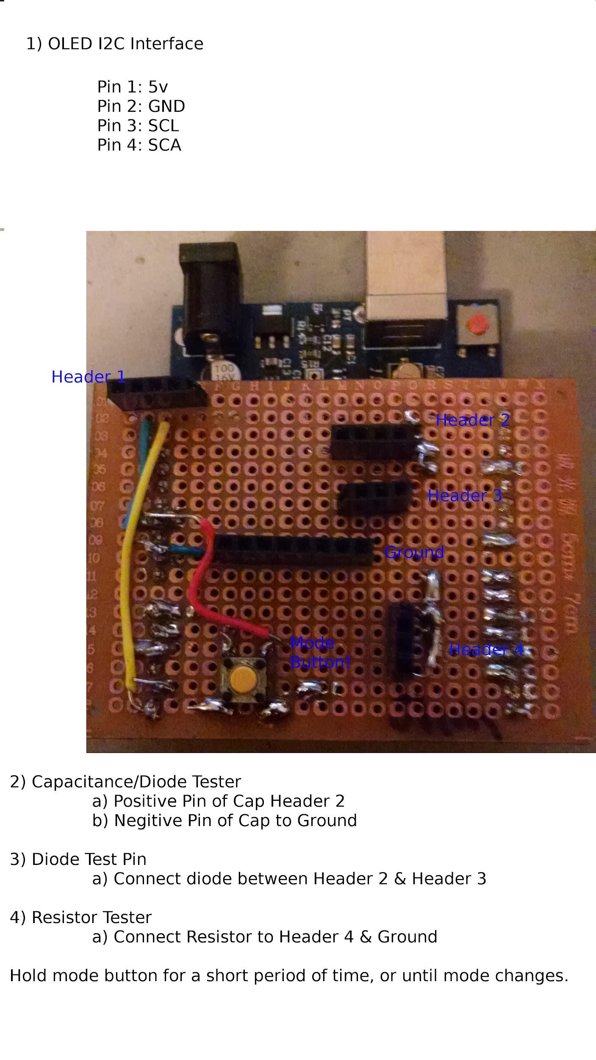

INFORMATION FOR ADDING INDUCTANCE TESTING:

<http://reibot.org/2011/07/19/measuring-inductance/>